**Fatal Police Shootings in the U.S. – Visual Analysis Report**

**1. Police Shootings per Million People by Race**

**Purpose:**  
This chart adjusts fatal police shooting counts for the relative population size of each racial group in the U.S., allowing fair comparison.

**Key Observations:**

* Black victims have the **highest per capita rate**, significantly above the national average.
* Native American victims also face disproportionately high rates compared to their share of the population.
* White and Hispanic/Latino rates are lower in per capita terms but still significant in raw numbers.

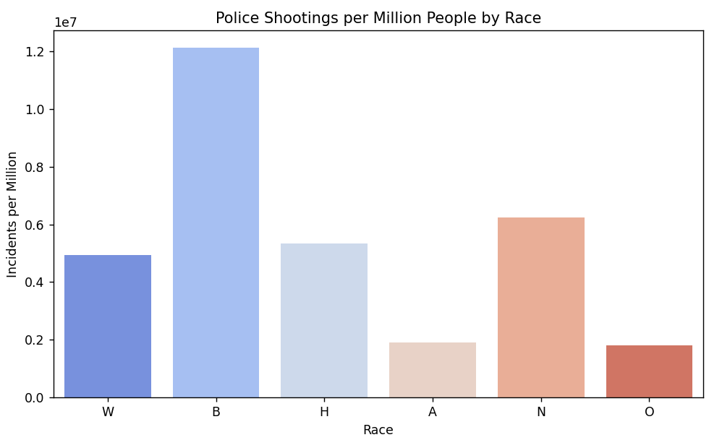

**2. Shootings per Year**

**Purpose:**  
To identify long-term trends in fatal police shootings from the dataset's start year to its most recent entry.

**Key Observations:**

* Incident counts fluctuate year to year, with **notable peaks in 2018–2019**.
* A slight drop is observed during the early pandemic years, potentially due to reduced public mobility and altered policing activity.

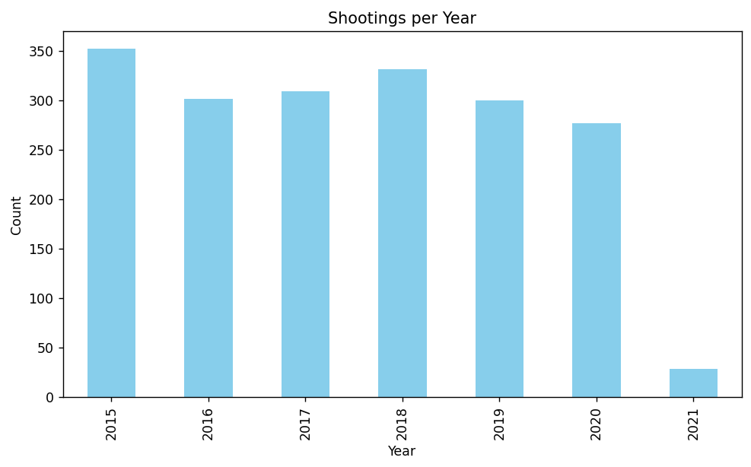

**3. Shootings by Day of Week and Race**

**Purpose:**  
To explore whether fatal shootings occur more frequently on certain days and how racial distribution changes across the week.

**Key Observations:**

* Midweek (Tuesday–Thursday) and weekends show slightly higher incident counts.
* Racial distribution remains consistent across weekdays, with White victims having the highest total counts, but Black victims are still overrepresented proportionally.

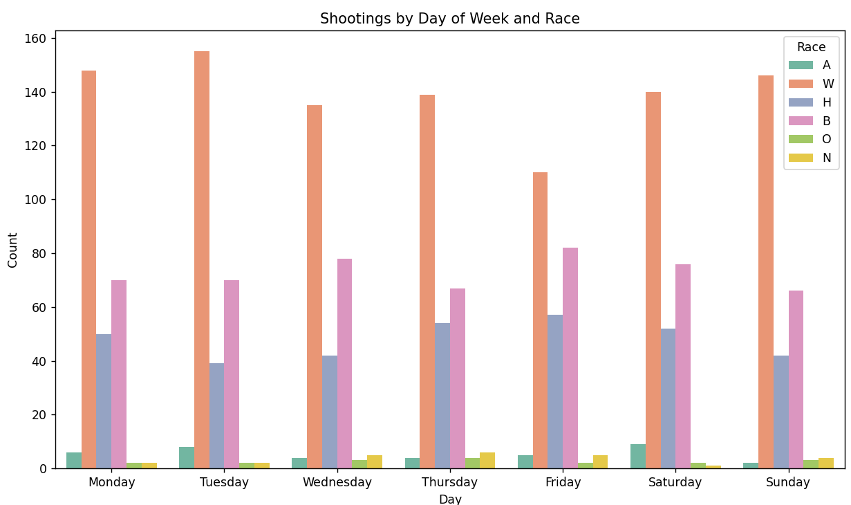

**4. Age Distribution of Victims**

**Purpose:**  
To understand which age groups are most affected by fatal police shootings.

**Key Observations:**

* Victim ages cluster heavily between **25–40 years**.
* Very few incidents involve minors (<18) or elderly individuals (>65).
* The age trend aligns with crime involvement patterns and higher police-citizen interaction in working-age groups.

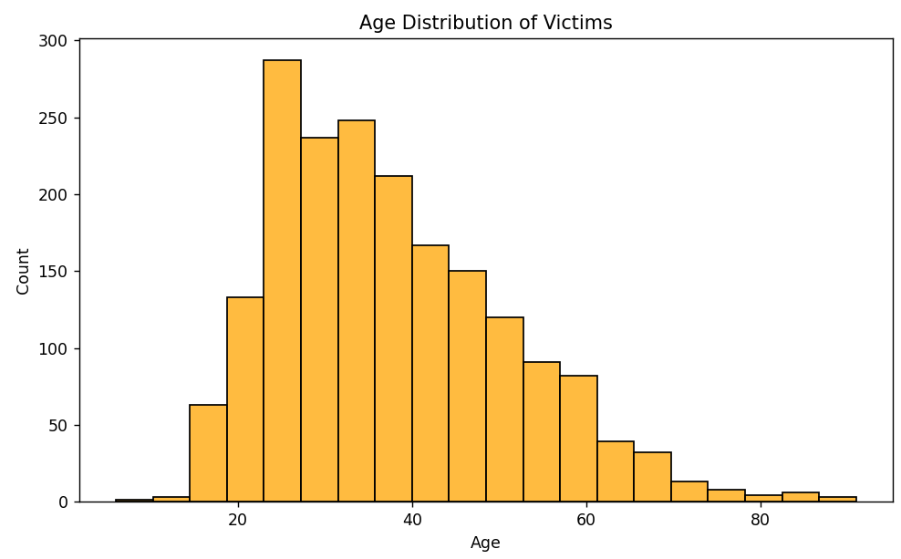

**5. Gender Distribution of Victims**

**Purpose:**  
To assess gender disparities in fatal police shooting victims.

**Key Observations:**

* The vast majority (~95%) of victims are **male**.
* Female victims represent a small fraction of incidents, suggesting gender plays a role in police-citizen dynamics.

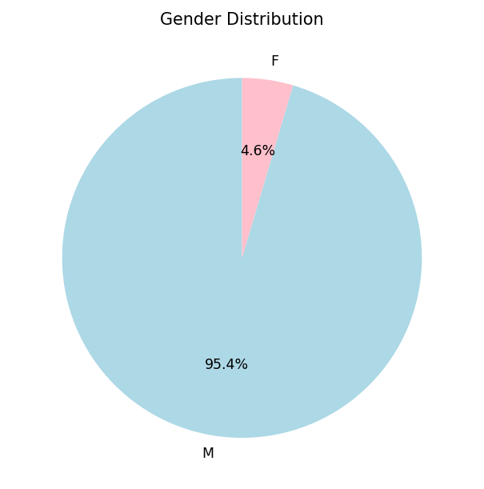

**6. Top 10 States by Shootings (Race Distribution)**

**Purpose:**  
To identify the states with the highest fatal shooting counts and show racial breakdowns within each state.

**Key Observations:**

* **California and Texas** have the largest raw numbers of fatal shootings.
* Some states with smaller populations (like Arizona and Colorado) appear due to higher per capita rates.
* Racial distribution varies by state, influenced by demographics and policing practices.

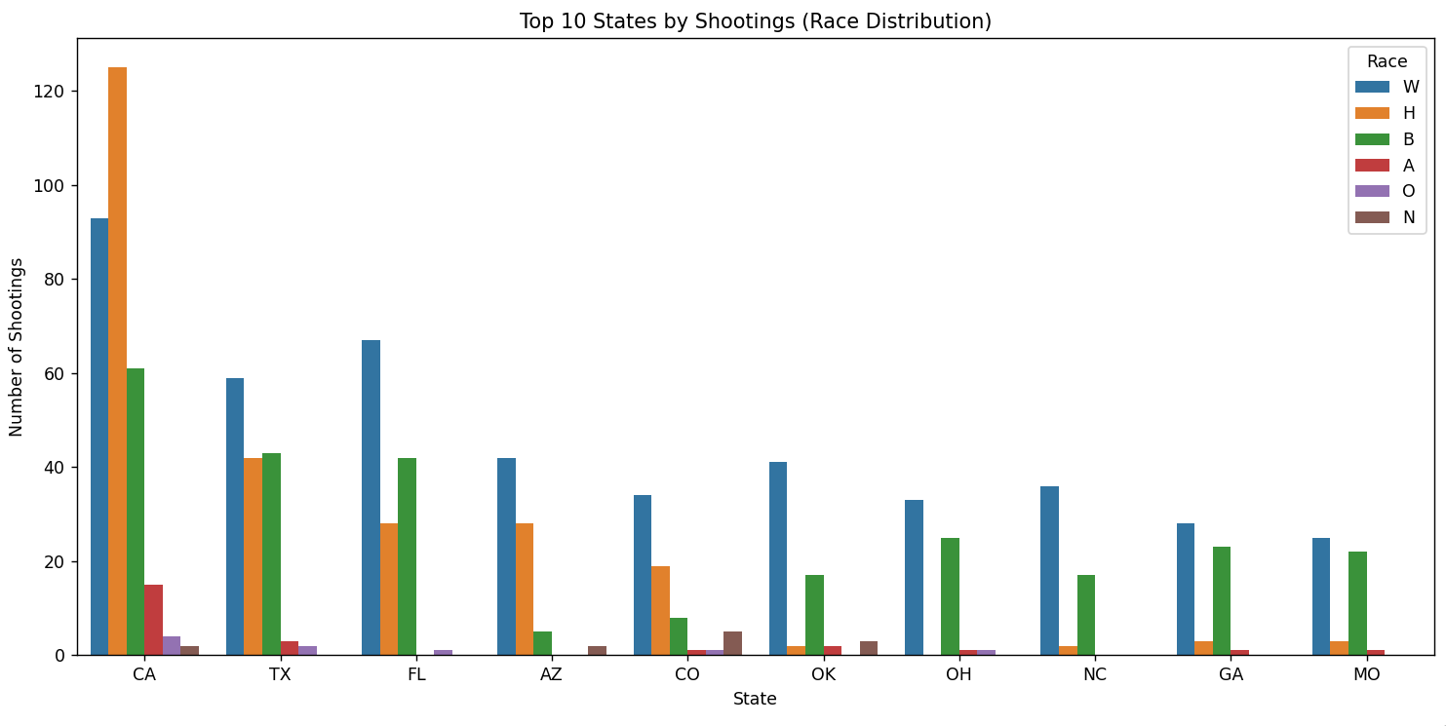

**7. Victims with Signs of Mental Illness**

**Purpose:**  
To evaluate the prevalence of mental health crises in fatal police encounters.

**Key Observations:**

* A notable portion of victims (often over 20%) showed **signs of mental illness** during the incident.
* This underscores the need for improved crisis intervention training and mental health response units.

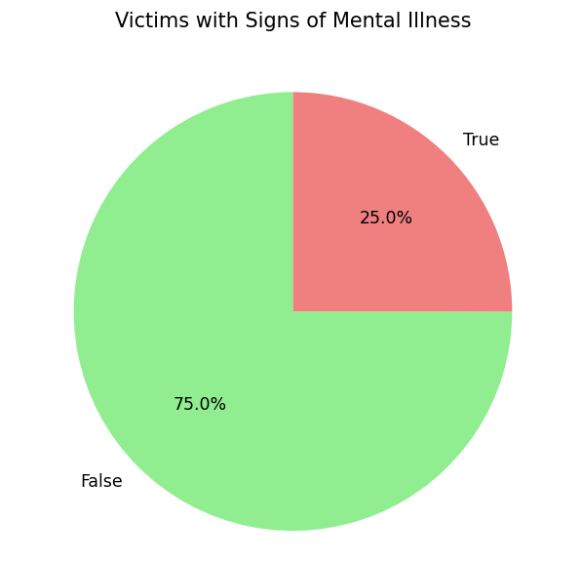

**8. Correlation Matrix**

**Purpose:**  
To explore relationships between numeric variables in the dataset.

**Key Observations:**

* Age shows weak correlation with most variables.
* No strong positive or negative correlations suggest that fatal shootings are influenced by a mix of non-numeric, situational factors.

